**Assignment 3: Fun with Process and Memory**

2.39:

Three child process are created upon execution.

2.40:

In round-robin scheduling, each process is assigned a time interval, during which it is allowed to run. If a process occurs twice in a list then with each process it will get two turns. One reason for allowing this would be to implement a priority system.

2.45:

Job → running times, priority

A → 10,3; B → 6,5; C → 2,2; D → 4,1; E → 8,4

For each of the following scheduling algorithms, determine the mean process turnaround time. Ignore process switching overhead.

a). Round Robin:

b). Priority Scheduling:

Average turnaround = (6+14+25+27+31) / 5 = 20.6 minutes

c). First-come, first served (run in order 10,6,2,4,8)

Average turnaround = (11+17+19+23+31) / 5 = 20.2 minutes

d). Shortest job first:

Average turnaround = (2+6+12+20+31) / 5 = 14.2 minutes

3.7:

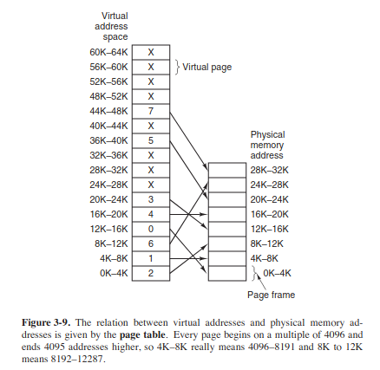

a) 20: page 0 (va = 0), offset = 20

b) 4100: page 1 (va = 4096), offset = 4

c) 8300: page 2 (va = 8192), offset = 108

3.13:

Formula for effective instruction time = (k + n) / k

3.16:

Given the following data about a virtual memory system:

a). The TLB can hold 1024 entries and can be accessed in 1 clock cycle (1 nsec)

b). A page table entry can be found in 100 clock cycles or 100 nsec

c). The average page replacement time is 6 msec

If page references are handled by the TLB 99% of the time, and only 0.01% lead to a page fault, what is the effective address-translation time?

**Answer:**

Address-translation time = P(TLB) X Time(TLB) + P(no page fault) X Time(page table) + P(page fault) X Time(replacement)

P(TLB) = 0.99; T(TLB) = 1nsec; P(no page fault) = 0.0001; T(page table) = 1 msec = 6000000;

P(page fault) = .00999; T(page table) = 100

= (.99 X 1) + (.0001 X 6000000) + (.0099 X 100) = **601.98 nsec**

3.29:

Consider the page sequence of the figure below:

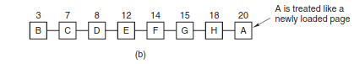

Suppose that the *R* bits for the pages B through A are 11011011, respectively. Which pages will second chance remove?

**Answer:**

The second chance algorithm will remove page D